Note: PHP in command-line mode and in web-interface mode can use different php. ini files with different configuration and different extensions.

5. Create a new database and configure it in the generated common/config/main-local.php file.

6. Apply the application migrations:

php yii migrate

This command will automatically create a user table in your database.

7. Try to run a frontend application by the following console command:

php yii serve --docroot=@frontend/web --port=8080

Then run the backend in an other terminal window: php yii serve --docroot=@backend/web --port=8090

8. Check in your browser that the application works via the http: //localhost: 8080 and <http://localhost:8090> addresses:

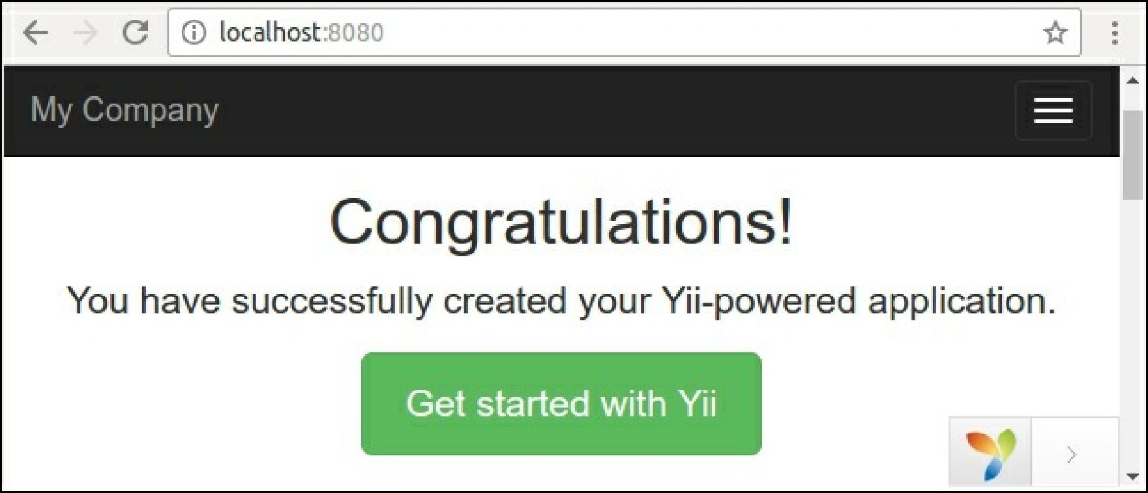

Create two new hosts for backend and frontend application in your server (Apache, Nginx, and so on) and set the backend/web and frontend/web directories as document roots of the hosts.

How it works...

First of all, we installed the Composer package manager and the Bower asset plugin.

After we installed the application via the composer create-project command, the command creates a new empty directory, clones the source code of application template and loads all its inner dependencies (framework and other components) into the vendor subdirectory.